UNITED STATES ARMY AVIATION WARFIGHTING CENTER
FORT RUCKER, ALABAMA
31 July 2026



STUDENT HANDOUT
CH-47D TRANSMISSION AND DRIVE SYSTEM

PFN 011-0413

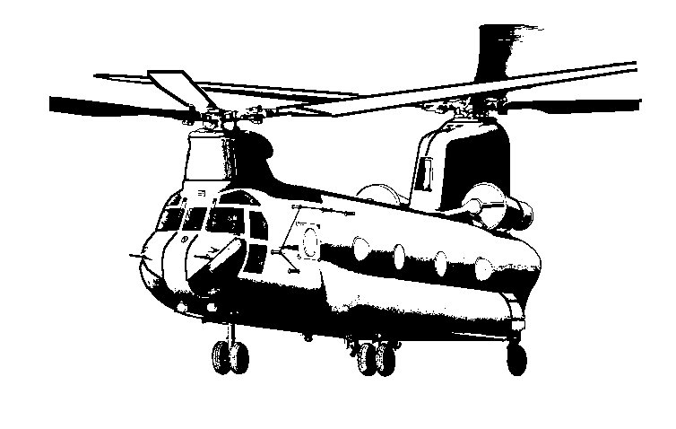

PROPONENT FOR THIS STUDENT HANDOUT IS:
110 Aviation Brigade, 223-A, MTPC
ATTN:ATZQ-ATB-CA
Fort Rucker, Alabama 36362-5000

FOREIGN DISCLOSURE RESTRICTIONS: The Materials contained in this student handout have been reviewed by the Instructor/Developer and determined to be public domain materials. This product is releasable to military students from all foreign countries without restrictions.

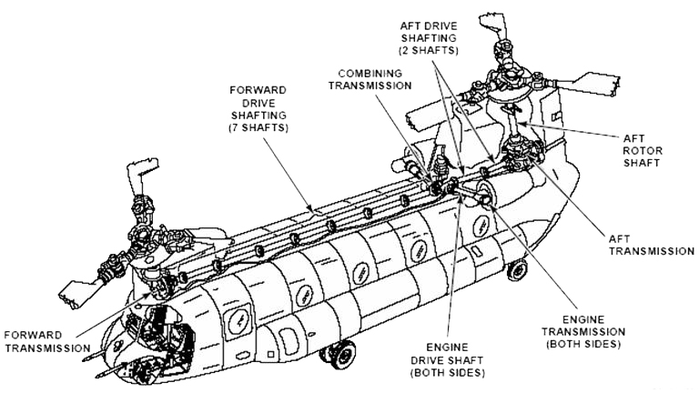

Terminal Learning Objective | At the completion of this lesson, you [the student] will:
 | Action: | Explain the components and operation of the CH-47D Transmission and Drive systems.
 | Condition: | Given training aids, technical manuals, and a student handout.
 | Standard: | correctly answer 4 of 5 questions from this lesson  (011-0413) on Written Exam 011-4270.

Section 1: Components of the Transmission and Drive System.

- Engine Transmissions
  - Location
    - Mounted to the forward end of each engine.
    - They are identical and can be used in either position by making a minor mechanical conversion.
  - Specifications
    - Weight 128 pounds each.
    - Operating oil is DOD-L-85734 (“Barney” Oil, Fig 1), MIL-L-7808, MIL-L-23699
    - Reservoir capacity is 6 quarts, located on C-Box.
    - System capacity is 11.1 quarts.

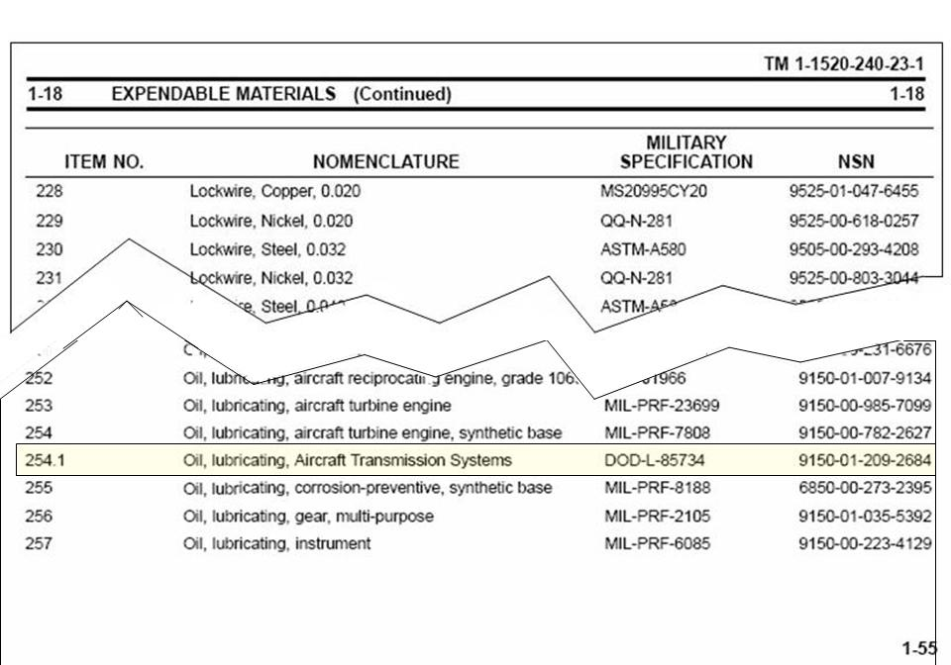
"Barney" or “555, triple nickel” Oil

- Engine drive shafts.
  - Two types of drive shafts.
    - Three piece drive shaft; ends are riveted onto shaft, balanced as an assembly.
    - One piece drive shaft; machined as a single shaft, balanced individually.
- Synchronizing shafting.
  - 7 shafts forward of C-Box, number 7 used for drive shaft alignment check.
  - 2 shafts aft of C-Box, number nine used to phase the aircrafts rotor system.
  - Shaft numbers 2-6 are interchangeable.
  - Shaft numbers 7 and 9 do not come with an adapter assembly.
- Aft vertical shaft.
  - Located inside the aft pylon between the aft transmission and the aft rotor head centered on station 560, Waterline +119.28
  - Splined to the aft transmission.
  - Entire shaft rotates, does not contain a separate shaft that rotates independently.
- Combining transmission.
  - Location is just in front of the aft pylon assembly, centered on station 463, waterline 56.
  - Specifications.
    - Weighs 416 pounds (Lbs).
    - Type oil is DOD-L-85734, MIL-L-7808, MIL-L-23699.
    - Reservoir capacity is 14 quarts.
    - System capacity is 22.1 quarts.
- Forward transmission.
  - Located in the forward pylon torque box, centered on at station 93, waterline 56.
  - Specifications.
    - Weighs 1186.0 pounds.
    - Operates on DOD-L-85734, MIL-L-7808, MIL-L-23699.
    - Sump capacity is 18 quarts.
    - System capacity is 27.9 quarts
- Aft transmission.
  - Located in the aft pylon just above the ramp area, centered on sta. 560, waterline +56.
  - Specifications.
    - Weighs 982 pounds.
    - Operates on DOD-L-85734, MIL-L-7808, MIL-L-23699.
    - Sump capacity is 40.0 quarts.
    - System capacity is 44.0 quarts.

Section 2: Synchronizing Drive shafts.

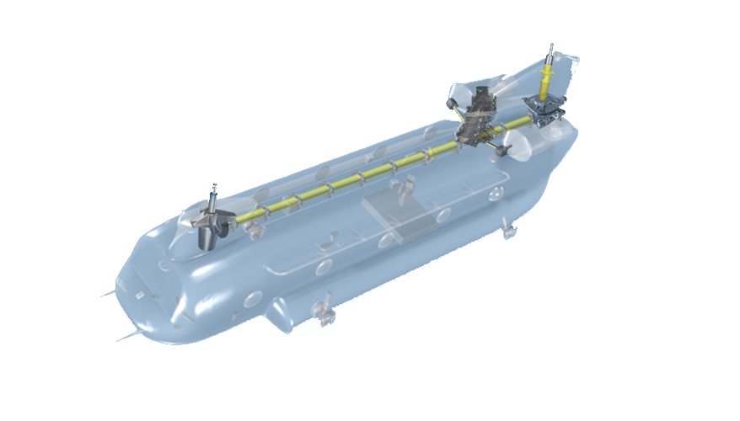

NOTE: During single engine operations the opposite engine transmission is receiving lubrication even when the engine is shut down.

CAUTION:
The N2 section of the second engine starts turning when the first engine is started; however, the lubrication system of the second engine is driven by the N1 section which does not begin to turn until the start sequence is initiated. Delay in starting the second engine will result in excessive wear on the N2 bearing package and seal. Start the second engine within three minutes of the first.

- Engine drive shaft:
  - Transmits torque from the engine transmission to the combining transmission.
  - Consists of a shaft, two plate and adapter assemblies.
  - The engine driveshaft, inboard and outboard adapters are a balanced assembly.
  - The outboard adapter assembly is secured (torqued) to the engine transmission.
  - Adapter plate assemblies strength is derived from assembling plates so that the grain of the metal is being crossed similar to that of plywood construction.

NOTE: Shot-peening is a cold working process in which the surface of a part is bombarded with small spherical media called shot. Each piece of shot striking the material acts as a tiny peening-hammer, imparting to the surface a small indentation or dimple. In order for the dimple to be created, the surface fibers of the material must be yielded in tension. Below the surface, the fibers try to restore the surface to its original shape, thereby producing below the dimple, a hemisphere of cold-worked material highly stressed in compression.

- Damage criteria for drive shafting are as follows (There shall be no such damage) Ref., TM 1-1520-240-23-5; Task 6-10.
  - Cracks in tube.
  - Dents in tube more than ½ inch diameter or 0.020 inch deep.
  - Distance between any two dents less than 3.50 inches
  - More than one dent around tube at any one station.
  - Distance between end flange and any dent less than one inch.

NOTE: Adapter assemblies have a shot-peened surface and cannot be repaired.

NOTE: Ensure that a technical inspector checks the retaining nut prior to installing the engine driveshaft as it cannot be seen upon completion of the work.

- Forward and aft synchronizing shafting.
  - Seven sections between the combining and forward transmissions.
  - Two sections between the combining and aft transmissions.
  - Bearing and support assemblies, six each support the drive shafting.
  - Adapter and plate assemblies, eight each allow the shafts to flex.
  - Shock mounts allow the shafts to move longitudinally.

NOTE: There are two different shock mounts brown and more common black made by the same manufacturer. Each shaft may have brown or black shock mounts, but they may not be intermixed on the same shaft.

  - The number seven shaft is also utilized for the driveshaft alignment check.

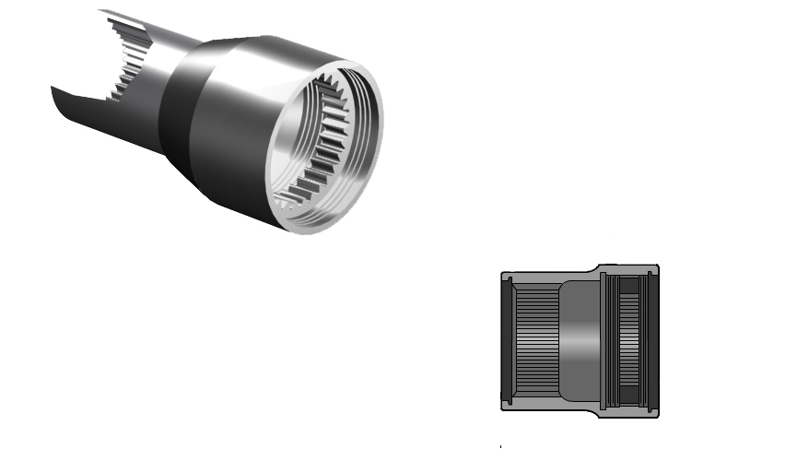

NOTE: The combining transmission forward output adapter includes an adjustable coupling which is used for the driveshaft alignment check. (Ref., ETM 1-1520-240-23-5, TASK 6-20).

  - The number nine shaft is also utilized for phasing the rotor system.
- Aft vertical shaft.

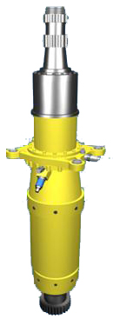

  - Located inside the aft pylon on top of the aft transmission.
  - Transmits power to the aft rotor system.
  - Splined to the aft transmission.
  - Aft rotor, drive arm, and centrifugal droop stops are attached.
  - Thrust bearing assembly.
  - Bolted to the aircraft in the aft pylon structure, retaining the shaft to the aft transmission.

CAUTION:
Exceeding VNE with LCT retracted places excessive stress loads on the thrust bearing.
Reference: TM 1-1520-240-MTF, figure FO-18

NOTE: The aft vertical shaft is in no way mounted or bolted to the aft transmission. It is splined to and driven by the aft transmission. One must ensure that the mount bolts are installed from the bottom up and that proper thread protrusion exist 0.08 to 0.20.

Section 3: Engine Transmissions.

- Location.
  - Mounted to the forward end of each engine.
    - Identical and can be used in either position through a minor mechanical conversion.

NOTE: New or rebuilt transmission comes set for number one side.

    - A sprag (or spring) clutch in each engine transmission allows the rotor system to overrun the engine system during single engine operations and autorotation.
    - The clutch engages when power is applied to drive the rotor system, and disengages when torque from the engine is removed.

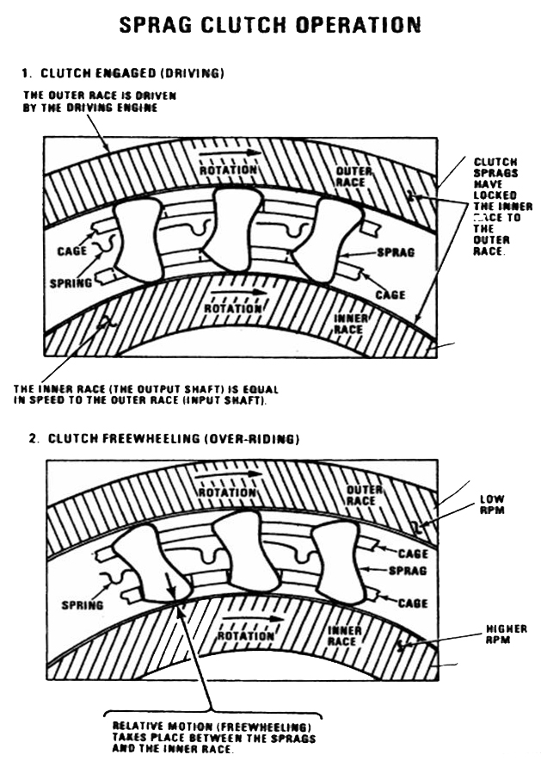

    - Torque is transmitted from the engine to the engine transmissions through a quill shaft to the combining transmission.
      - A snubber is installed between the quill shaft flange and the end of the engine transmission pinion gear, to prevent metal-to-metal contact.
      - The correct installation and direction of the snubber must be check by a technical inspector (or Maintenance Test Pilot in some circumstances) during installation of the engine transmission in accordance with TM1-1520-240-23, task 6-107 under “inspect”.

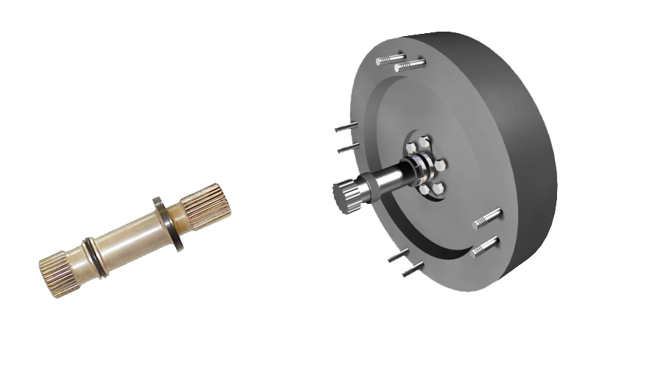

      - The overall gear reduction ratio is 1.23:1.
    - Configuring an engine transmission for installation in an opposite side consists of the following actions:
      - Moving the dowel pin.
      - Changing the plugs and hose fittings.
      - Re-locating the chip detector and temperature bulb/switch
      - Installing to a different set of mounting holes.
- Specifications.
  - Weight 128 pounds each.
  - Dimensions, 19 inches long, 16 inches wide and 16 inches high.
  - Operating oil is DOD-L-85734, MIL-L-7808, MIL-L-23699.
  - Reservoir capacity is 6 quarts.
  - System capacity is 11.1 quarts.
  - Quill shaft.
  - Transmits torque from engines to engine transmission.
    - Visually check for cracks, chipping, erosion of plating or distortion, no such damage is allowed. Ref: TM 1-1520-240-23-5, Task 6-101 (Instructor, go to task in appropriate manual and explain).
- Snubber:
  - Inspect for tears, holes, or erosion. There shall be no such damage. Ref: TM 1-1520-240-23-5, Task 6-101.

NOTE: A Technical Inspector must visually inspect quill shaft and snubber any time the engine transmission is removed.

- Oil pump.
  - Rated speed is 6002 RPM at 100%.
  - Rated flow is 6.0 Gallons per minute (GPM) pressure and 18.0 GPM scavenge.

NOTE: Number 1 Engine transmission is pressurized by the c-box main oil pump and the #2 engine transmission is pressurized by the c-box aux oil pump.

- Oil filters.
  - Adjustable valve set to: 65 PSI.
  - Range of adjustment: 45-85 PSI.
  - Filter bypass valve operates when total pressure drop exceeds: 25-30 PSID.
  - Impending bypass indicator button extends when pressure differential across element exceeds: 15-18 PSID.

NOTE: Thermonic lockout prevents indicator button activation if below: 115 degrees F + 10 degrees F. (Boeing Book 46 degrees Celsius plus or minus 5 degrees C) (T-Manual 170-185 degrees Fahrenheit) both references.

- Oil cooler.
  - Rated oil flow is 14 GPM.
  - Temperature/pressure bypass valve redirects oil to bypass cooler core when outlet temperature is 160 + 10 degrees F (71 + 5 degrees C).
  - Bypasses oil when core differential drop exceeds: 30 + 5 PSID.
- Transmission Oil Pressure.
    - The cockpit XMSN oil pressure indicator indicates the oil pressure.
    - The indicator is electrically connected to the pressure transducer.
    - The transducer is located behind the C-Box on the bulkhead, and operates on 115 AC from the number 1 PDP.
- Pressure switches are located within the screen support assemblies for the number one and number two engine transmissions.
  - The number one and number two pressure switches turn on a light on the maintenance panel indicating pressure loss.
- Transmission Oil Temperature.
  - XMSN oil hot light reading taken from the combining transmission reservoir utilizing temp bulb.
  - XMSN hot light reading taken from Eng XMSN temp bulb incorporated with the chip detector.
- Transmission Chip Detector.
  - On front of Eng XMSN (wired with eng chip light, use maintenance panel to identify).
- Engine Transmission Debris Detection Screen.
  - Two stainless steel screens, a positive and a negative, are in each detector.
  - The screens are formed around woven polyester monofilaments.
  - The No. 12 mesh openings are 0.060 inch.
  - All return oil is routed through the debris screen prior to being returned to the reservoir.
  - Electrically conductive particles bridging the positive to negative elements activate the debris screen latch indicators on the maintenance panel.
- Engine Transmission Lubrication System.
  - Engine transmission oil flows from the reservoir thru the pump, filter, cooler, and jet protection screen (last chance filter) to the jets which spray oil onto the various gears and bearings.
  - A scavenge element returns the oil from the transmission sump thru an indicating screen and back to the reservoir.
  - Engine transmissions do not have auxiliary lubrication systems.
  - All Engine transmission lubrication system components are within the combining transmission except the jets.
  - Ref: TM 1-1520-23-5, task 6-194, contamination analysis of engine transmission and task 6-198, engine transmission serviceability check.

Section 4: Combining Transmission

- Combining transmission.
  - Receives torque from both engine transmissions and distributes the combined torque to the forward and aft transmissions.
  - Utilizes two spiral bevel input gears and a single spiral bevel ring gear which changes the angle of drive forward and aft, (approximately 90 degrees).
  - A speed reduction of 1.77:1 occurs within the combining transmission.
- Location.
  - The combining transmission is located in the front of the aft pylon, centered on station (STA) 463, waterline (WL) 56, buttline (BL) 0. Access to the combining transmission is made by opening the aft pylon leading edge fairing and removing the combining transmission fairing.
- Specifications.
  - Weighs 416 pounds (Lbs).
  - Dimensions are 35 inches long, 16 inches wide and 48 inches high.
  - Type oil is DOD-L-85734, MIL-L-7808, MIL-L-23699.
  - Reservoir capacity is 14 quarts.
  - System capacity is 22.1 quarts.
- Transmission oil pressure.
  - At ground idle minimum oil pressure required is 7 PSI.
  - Flight (normal operations) minimum oil pressure is 20 PSI.
- Transmission oil temperature.
  - Maximum oil temperature 140 degrees C.
  - Reading taken at the combining transmission reservoir.
- Oil pump.
  - Rated speed is 6002 rpm at 100% RRPM.
- Oil filters.
  - Adjustable valve set to: 65 PSI.
  - Range of adjustment: 45-85 PSI.
  - Filter bypass valve operates when total pressure drop exceeds: 25-30 PSID.
  - Impending bypass indicator button extends when pressure differential across element exceeds 15-18 PSID.
  - Filter indicator button on combining transmission cannot be reset without removing the filter housing and turning it upside-down to reset check-ball.

NOTE: Thermonic lockout prevents combining transmission main oil filter indicator button activation if or below: 115 degrees F + 10 degrees F. (46 degrees C + 5 degrees C).

- Main oil inlet screens (Last chance filters) mounted next to pressure switch just prior to the lubrication jets.
  - Auxiliary oil filter is a wire mesh that can be cleaned and reinstalled (recommend replacement).
  - Debris detection screens are installed in the pump scavenge system. Oil flowing thru the screens depositing electrically conductive particles between the screen complete the circuit to operate the L/H and R/H debris screen latches on the maintenance panel.
- Oil pressure-indicating system.
  - The cockpit XMSN oil pressure indicator provides a visual representation of the oil pressure.
  - The indicator is electrically connected to the pressure transducer.
  - The transducer is Located behind the C-Box on the bulkhead, operates on 115 AC on #1 PDP.
  - Main oil pressure switch activates caution light and maintenance panel at the same time if low.
  - Oil pressure exists (below 20 PSI for the main and 10 PSI for the AUX).
- Oil cooler.
  - Mounted on top of the combining transmission, has 14 GPM flow rate.
  - Temperature/pressure bypass valve redirects oil to bypass cooler core when outlet
  - Temperature is 160 + 10 degrees F (71 + 5 degrees C), or a 30 + 5 PSID condition exist.
- Cooler fan.
  - The fan driveshaft (29 inches long) is mounted to the accessory drive on the aft portion of the combining transmission and goes through the reservoir housing between the two engine transmission reservoirs.
  - Fan is mounted on top of the oil coolers and the air is pulled through the three coolers and is exhausted up through the screens mounted on top of the aft pylon between STA 482 and STA 534.

NOTE: Ensure proper lubrication of the cooler fan bearing is accomplished to prevent bearing failure. Failure of fan bearings would cause failure of cooler fan driveshaft.

Section 5: The Forward Transmission

- Forward transmission.
  - Mounted in the torque box in the forward pylon, centered at sta. 93, waterline 56.
  - Access is made by opening the forward pylon work platforms and removing fairings as required. The acoustic blanket and drip pan are removed from above the companion way.
  - Driven by the forward synchronizing shafts, the forward transmission changes the drive direction 81 degrees.
  - The vertical output shaft drives the rotary wing head.
  - The overall gear reduction ratio is 30.72:1.

NOTE: Care must be taken when installing the forward rotary wing head, if threads on output shaft are damaged the entire transmission must be replaced.

- Specifications.
  - Weighs 1186.0 pounds
  - Dimensions are 51 inches long, 20 inches long and 67 inches high.
  - Operates on DOD-L-85734, MIL-L-7808, MIL-L-23699
  - Reservoir (sump) capacity is 18 quarts.
  - System capacity is 27.9 quarts
  - Transmission oil pressure limitations are: Main 20 PSI Aux 20 PSI during normal operations 100% RRPM. Ground operations minimum oil pressure is 7PSI.
- Oil pump.
  - Rated speed is 5334 rpm at 100% RRPM
  - Rated flow is 20 GPM.
  - Pressure relief adjusted to 60 PSI.
  - Range of adjustment is 40 to 70 PSI.
- Oil filter.
  - Filter bypass valve operates when total pressure drop exceeds 25 to 30 PSID.
  - Indicator button extends when there is a differential pressure of 15 to 18 PSID.
  - Thermonic lockout prevents indicator button activation at or below 115 + 10 degrees F (46 +5degrees C).
- Oil cooler.
  - Rated oil flow is 19 GPM.
  - Temperature/pressure bypass valve redirects oil to bypass cooler core when outlet
  - temperature is 160 + 10 degrees F (71 + 5 degrees C)
  - Bypasses oil when core differential drop exceeds: 30 + 5 PSID.
- Oil cooler impeller
  - The oil cooler impeller (fan) is mounted on the forward transmission input shaft (fwd adapter).
  - The impeller guide vanes are mounted to the transmission and the oil cooler is mounted to the guide vanes.
  - The diffuser is mounted to the guide vane assembly and directs the air on to the impeller.

NOTE: Ensure that the three piece shroud is installed.

NOTE: Always replace pre-formed packings on the oil transfer tubes during installation of the oil cooler to prevent leakage and double work. There are two types of shrouds plastic and fiberglass they cannot be intermixed.

Section 6: The Aft Transmission

- Aft transmission.
  - Located in the aft pylon just above the ramp area, centered on sta. 560, waterline +56.
  - Access is made by opening the aft pylon baffle doors, the pylon side access panels, and the aft work platforms.
  - The Aft transmission receives torque input from the aft synchronizing drive shafts and changes the angle of drive 94 degrees to drive the aft rotor vertical shaft.
  - The overall gear reduction ratio is 30.72:1.
- Specifications.
  - Weighs 982 pounds.
  - Dimensions are 52 inches long, 34 inches wide and 35 inches high.
  - Operates on DOD-L-85734, MIL-L-23699, or MIL-L-7808 in cold temperature.
  - Reservoir capacity is 40.0 quarts.
  - System capacity is 44.0 quarts.
  - Normal operating oil pressure is main system 20 PSI at 100% RRPM and 20 aux.
  - Maximum oil temperature is 140 degrees C. Reading taken in the sump of the transmission by the temp bulb.
- Oil pump.
  - Rated speed is 5358 rpm at 100% RRPM.
  - Rated flow is 29.5 GPM and Scavenge is 5.0 GPM.
  - Supplies lubricating oil to the various gears and bearings in the aft transmission and to the aft rotor shaft bearing.
  - Main system oil flows from the sump thru the main oil pump, main filter, cooler, jet protection screen and to the various gears and bearings; In addition, after the oil leaves the jet protection screen, an alternate path routes some of the lubricating oil to the aft shaft bearing and cooling oil to the generators.
  - Auxiliary system oil flows from the auxiliary oil sump thru the auxiliary oil pump and filter then to the various auxiliary oil lubrication jets.

NOTE: The auxiliary system DOES NOT lubricate the aft shaft bearing or provide cooling for the main generators.

- Oil filter (30 Micron disposable)
  - Filter bypass valve operates when total pressure drop exceeds 25 to 30 PSID
  - Indicator button extends when there is a differential pressure of 15 to 18 PSID.
  - Thermonic lockout prevents indicator button activation at or below 115 + 10 degrees F (46 +5degrees C)
- Oil cooler.
  - Temperature/pressure bypass valve redirects oil to bypass cooler core when outlet temperature is 160 + 10 degrees F (71 + 5 degrees C).
  - Bypasses oil when core differential drop exceeds: 30 + 5 PSID.
  - Driven by a steel quill shaft 13.8 inches long that is splined at both ends. Each end of the shaft is identical. Is installed with two packings on each end to prevent grease from being slung out of splines.
- Aft Transmission oil pressure indicating system.
  - One difference between the aft and forward transmission oil pressure indicating system is that the aft transmission system incorporates a relay timer (146K1) located in the maintenance panel.

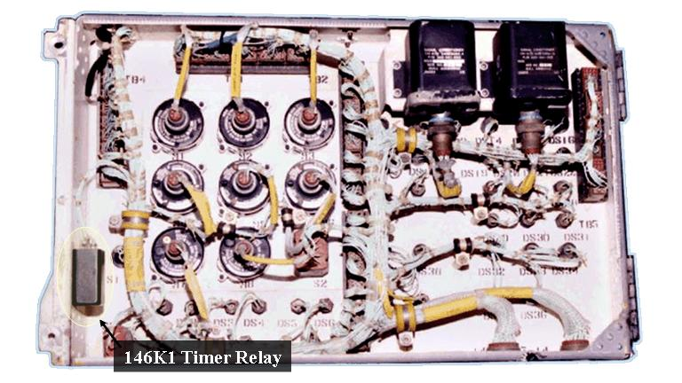
Maintenance Panel (rear)

  - The relay timer provides an 8-10 second delay (according to PS Magazine letter dated 26 September 1988) or 5-7 second delay (according to TM 1-1520-240-T, task 8-9.3, Note after step 14) in activating the aft transmission low oil pressure caution capsule on the maintenance panel and the XMSN OIL PRESS caution capsule on the master caution panel (without 74) or caution/advisory panel (with 74).
    - This relay rarely fails but remains important because, if the relay does fail, there will be no caution illuminated on either the maintenance panel or the master caution panel indicating low aft transmission main oil pressure.
    - The relay timer 146K1 operation is checked during the transmission oil pressure indicating system operational check.
.

